**Required software**

* Node Js

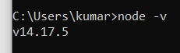

* Npm > npm install



* Dot Net Core 5.0 Visual studio 19/Visual studio code

***Run application***

* Go to the root directory

Npm install

Then use ng build

* Ng serve

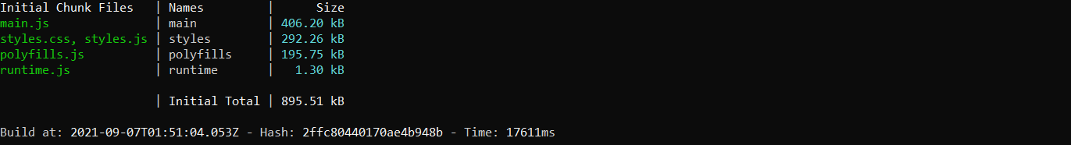

***Custom Library Details***



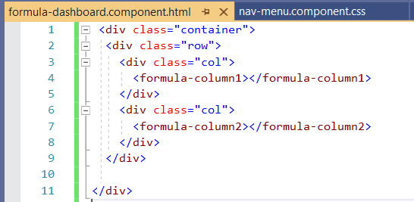

**Note: Attached library code also in code folder.**

Note: Please let me know if finding any issue while running the application.